Deliverable 4 Wireframes & Feature Plan
CSC 425 Fall 2025
Name: David Foote
Date Submitted: 9/19/25
GitHub REPO URL: https://github.com/MJONES155/CSC425_Assignment1.git
Branch Name: Deliverable4-DavidFoote

Low-Fidelity, Mobile-First Wireframes

Login Page
- Email, Password Input
- Remember Me Button
- Login Button
- Sign Up Button

Signup Page
- Email Input
- Password Input
- Meal Plan Selection (Not Final)
- Sign Up Button

Dashboard Page
- Account Overview
  - Spending Tracker Display (On Budget or Not)
  - Most Visited Restaurant Display
  - Daily Spending Amount (Amount Left for the Day)
- Budget Page Button
- Settings Menu (Not Completed) (Contains log out button)

Budgeting Page
- Spending Section
  - Total Spent
  - Weekly food budget
  - Other spending statistics (Flex Dollars, Meal Swipes, Meal Exchanges, Guest Meals, To-Go Meals)
- Current Position Section
  - Daily Spending Amount (Amount Left for the Day)
  - Other spending statistics (Flex Dollars, Meal Swipes, Meal Exchanges, Guest Meals, To-Go Meals)
- Budget Plan Section
  - Current Budget Plan Information (Default, or Custom)
  - Edit Budget Plan Button (Brings to an Edit Page) (Not Completed)
- Settings Menu (Not Completed) (Contains log out button)

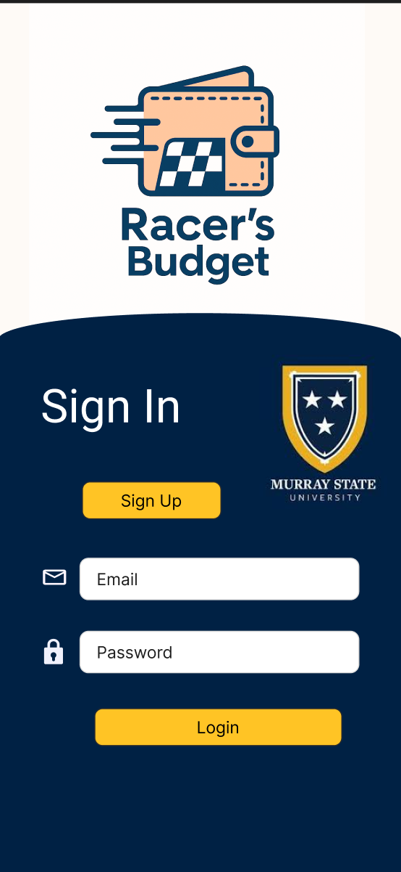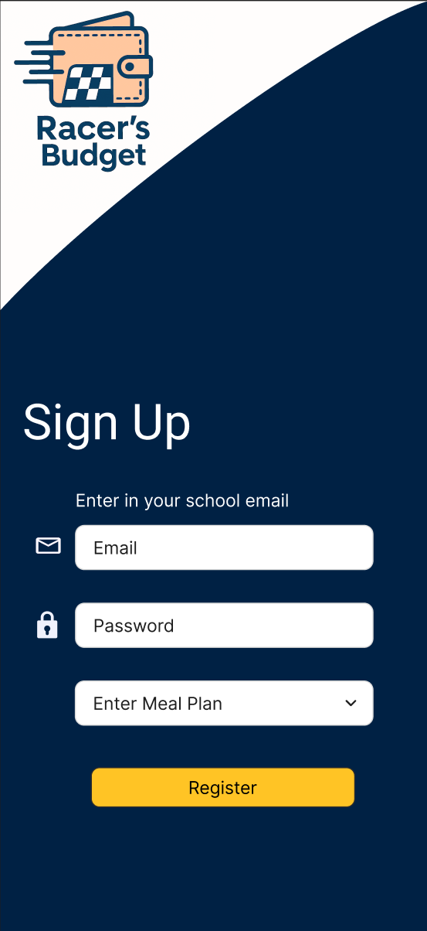

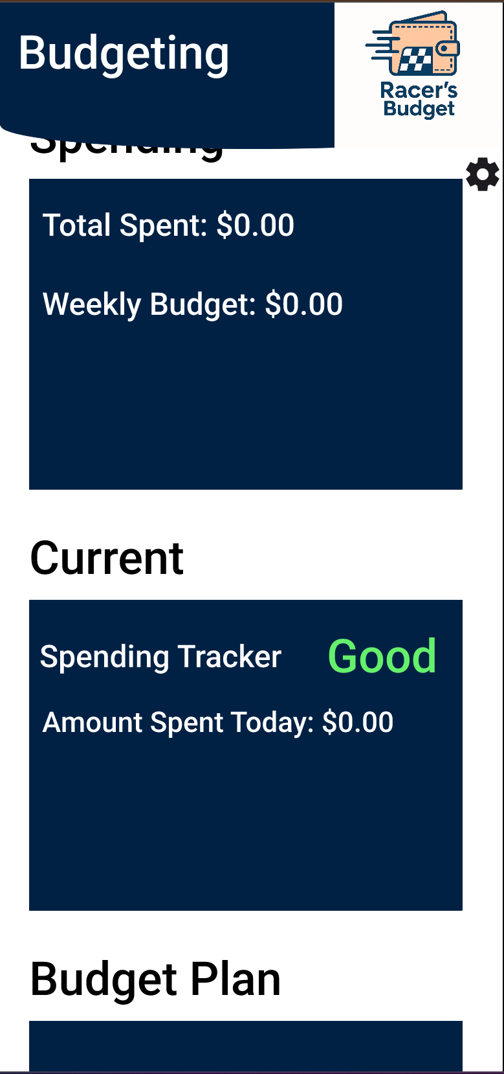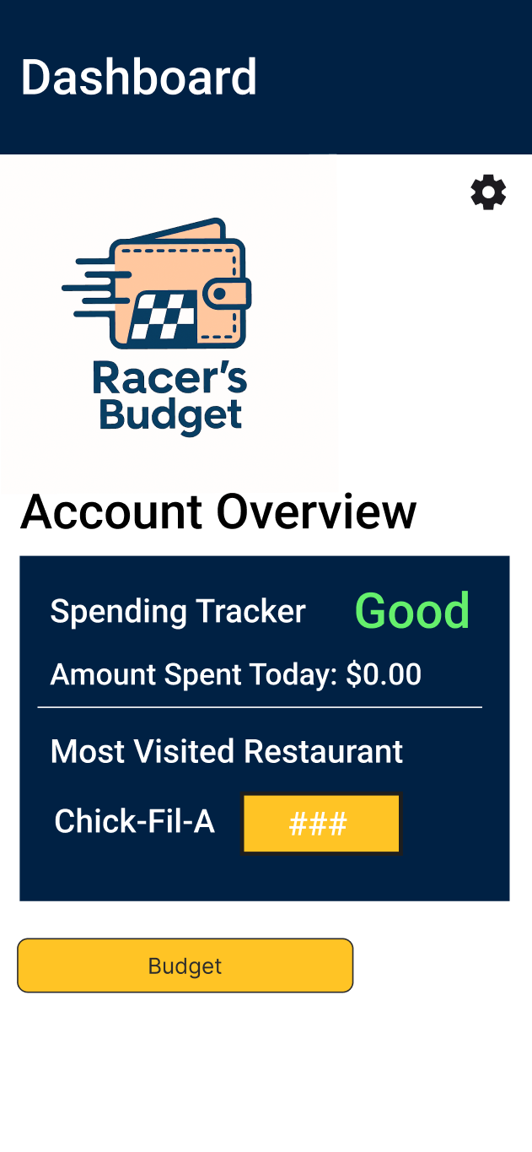

Functional Requirements

GENERAL REQUIREMENTS
- Mobile-first responsive design
- Error handling
- Session management (the “Remember Me” button)
- Data persistence (store user budget, spending history, and preferences)
- Analytics engine (Calculate numbers such as spending trends)
- Security (encryption of sensitive data like passwords and budget information)

CRUD OPERATIONS
- Create new user
  - Email and password
  - Connect to data base to determine meal plan
  - If not connect, choose meal plan.
  - If not connect, choose how much spent.
- Update user
  - Change email
  - Change password
  - Change meal plan
- Delete user

AUTHENTICATION
- Verify user
  - Checks email
  - Sends a verification email
  - Checks password
  - Check database for user’s meal plan

DISPLAY DATA
- Data retrieval
- Real-time updates
- Responsive layout

User Stories

- As a student, I want to be able to see my leftover flex, so I can budget for other things.

- As a student, I want to be able to plan ahead with my spending, so I don’t run out of money too early or have any money left over at the end of the year.

- As a student, I don’t want to create my own custom budget, but I still want to follow a budget.

- As a student, I want to be notified that I have not spent my weekly budgeted amount.

- As a student, I want to be able to know what restaurants that I have visited over the course of my semester.

Flow Diagram of User Journey
- Create Account
  - Input email (school email) and new password
  - Verify email
  - Input meal plan (or pulls information from database)
- Login to Account
  - Enter correct email
  - Enter correct password
- Dashboard Page
  - Short introduction to the different menus (FIRST TIME USER ONLY)
  - Examine dashboard content
  - User can switch to the settings menu or budget page
- Budgeting Page
  - Short introduction to the different menus (FIRST TIME USER ONLY)
  - Examine budget page content
  - Can use default or create a budget plan (ACCORDING TO THE USER’S MEAL PLAN)
- Log Out
  - Occurs when user is done using the app
  - Opens up the setting’s page and logs out or closes out of the application

